Locational Offset Correction
Final Report
1. Introduction
Crop yield prediction is a valuable tool for agronomists and policymakers. One challenge with many existing datasets is that of location accuracy. GPS locations for fields can end up offset from the true location due to sensor inaccuracies or from locations being collected at the edges of fields rather than the field centers. This makes it harder to connect remote-sensed data to the yield values.
The goal of this project is to produce a method that can help correct these location offsets by finding the most probable field center given an input location. We prepared and hosted a competition on Zindi where competitors model the problem using state-of-the-art techniques. We provide the competitors with satellite images of fields along with their corresponding manually annotated correct centers. Additionally, we also provide approximate plot size and measured yield in case these help with creating your solution.
The main data is a list of maize fields associated with images from Planet and Sentinel-2 satellites. Original positions are considered images' centers as (0,0) and a displacement vector for each field in the training set is provided. The goal to predict these vectors for each vector in the test set. To illustrate more the displacement vector, the following is an image with original position as blue point, corrected position as red point and the displacement vector between the two positions in yellow:

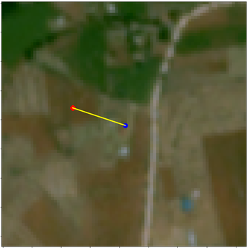
Figure 1 Example data sample where the blue at the center of the image is the original field center and the red is the corrected field center after adding the offset

In order to preserve the anonymity of the crop fields as well as prevent manual data annotation in the competition, we provide the target coordinates as relative offsets instead of absolute coordinates. Thus, the competitors cannot identify the absolute field coordinates, without affecting the performance of the solutions.

2. Data sources
Several data sources are provided in the competition and participants are allowed to use any of them.

2.1 Planet Lab images
These are images captured using Planet Lab Satellite [1] in ~4.7 m resolution in different timestamps: June’17, December’17, June’18, and December’18. Each image is 84*84 pixels and has RGB channels only. It should help identify the farm boundary and other objects inside beside Maize like houses and trees.

2.2 Sentinel-2 images
These are images captured using Sentinel-2 Satellite [2] in ~10 m resolution. Each image has 16 bands with 41*41 pixels for each of 12 months from the same year when the datapoint was taken, giving a total of 192 image bands. These images are aligned on the same area and centered around the same center as Planet Lab images. It should help in yield estimation for Maize fields.

2.3 Meta-data
These are variables captured during the yield estimation process in the field which include:
- yield estimate (kgs/m^2)
- field area (acres)
- year in which the yield estimation process was done
- annotation quality, available only in training and auxiliary data
All these data sources are available for training, auxiliary, extra, and test data. The annotation process applied on the auxiliary data is slightly different from what is applied on both training and test data, but it may prove useful when added in the training phase.

2.4 Extra Data
Since Sentinel-2 launched mid-2015, datapoints in this year have only 6 months as compared to 12 months for the rest of the datapoints. In order to provide the same length time series, we provide the 2016 Sentinel-2 time series for datapoints in 2015. This is to allow competition participants in developing uniform models on all the data.
We annotated an additional 999 datapoints. This is to improve the performance of machine learning models which rely heavily on the amount and quality of data.

2.5 Data Summary

Table 1 Summary of data sources according to both Split and Quality
 | Total | Quality 1 | Quality 2 | Quality 3
Train | 366 | 147 | 102 | 117
Auxiliary | 656 | 65 | 280 | 311
Extra | 999 | 503 | 257 | 239
Test | 1165 | 633 | 220 | 312
Total | 3186 | 1348 | 859 | 979

3. Data Collection
Planet images are provided as Mercator Web Tiles, which need to be processed to extract the bounding box surrounding the field. We developed the Planet-Box-Extractor API for this purpose.

3.1 Bounding Boxes using WGS84
Extracting a region of interest around a given longitude-latitude coordinate would be straightforward in case of a planar projection. However, for Earth surface patches, simply treating the geometry as if it were on a 2D plane results in weak approximations in case of small bounding boxes in low curvature regions. As for larger bounding boxes and higher curvature regions, the 2D plane projection approximation error becomes much higher. Figure 2 illustrates the ellipsoidal model of the Earth. For an interactive illustration of the difference between planar and spherical projection see [3].
More precise bounding box region calculation requires the utilization of cartography standards such as the World Geodetic System 1984 (WSG84) [4]. The WSG84 models the Earth as an ellipsoid with two radii: equatorial (or semi-major axis) and polar (or semi-minor axis). Projecting a region of interest onto the surface of the Earth involves some calculations as explained in [5].
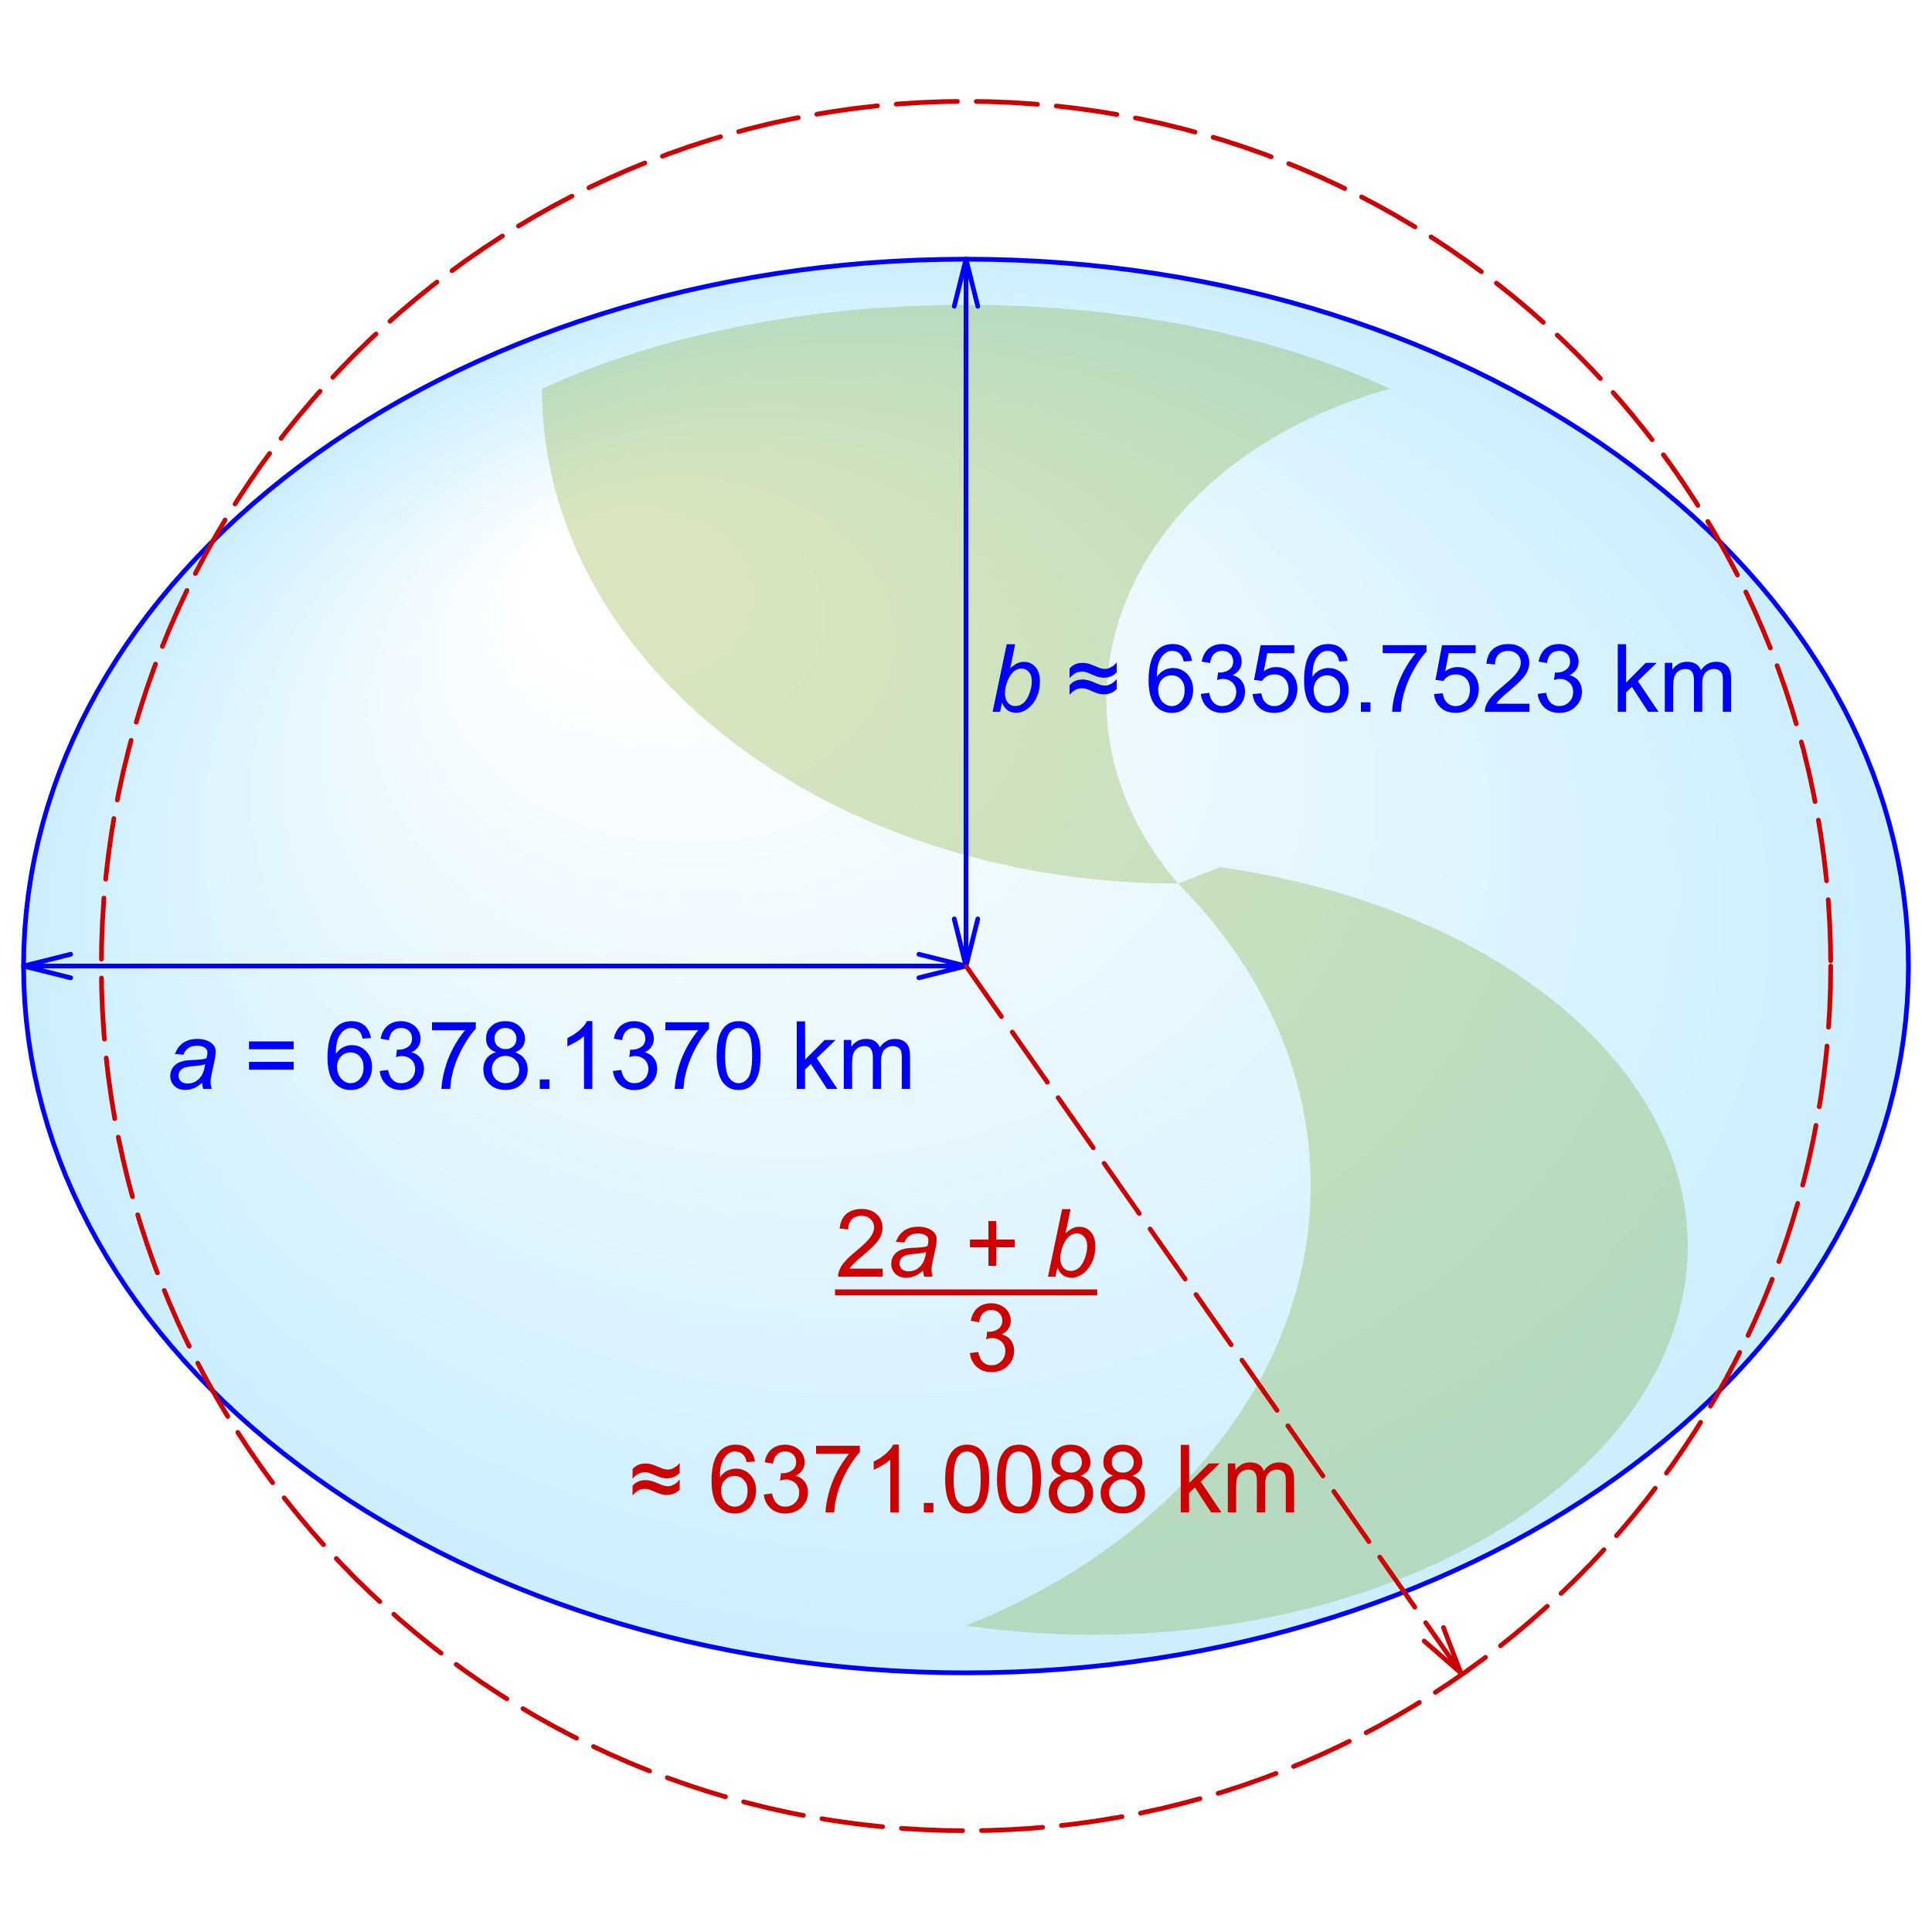
Figure 2 Equatorial (a), polar (b) and mean Earth radii as defined in the 1984 World Geodetic System revision (not to scale). Source: https://en.wikipedia.org/wiki/Earth_radius

3.2 Mercator Tiles
Tiling is the most common method of rendering maps on web application in seemingly continuous images [6]. Tiled maps are bandwidth-efficient since upon panning, many tiles remain the same, while retrieving only those needed. Web Mercator projection is the de facto standard for web tiles, using the cylindrical map projection introduced by the Flemish cartographer Gerardus Mercator in 1569. Figure 3 illustrates the borders of tiles on a map.

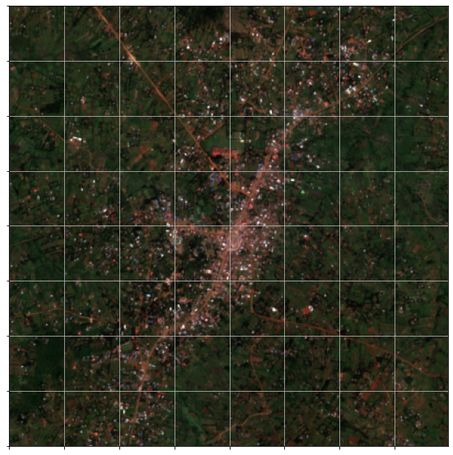
Figure 3 An example of a tiled web map. Tiled web maps are normally displayed with no gap between tiles. Source: Sentinel-2

Planet.com API [7] provides the following properties for tiled web maps:
- Tiles are 256 * 256 pixels.
- The lowest zoom level 0 represents a single tile for the entire planet.
- The highest zoom level can vary between different map providers; level 20 represents a mid-sized building.
- Tiles can be accessed with an XYZ naming convention, where Z is the zoom level, X and Y are the tile identifiers: https://tiles{0-3}.planet.com/data/v1/item_type/item_id/Z/X/Y.png
where “tiles{0-3}” are different servers indices, “item_type” is the type of the item to view, and “item_id” is the id of the item to view.
- To identify web tile given longitude and latitude:
$$n=2^{Z} \\ X=n*\left(\frac{longitude°+180}{360}\right) \\ Y=n*\frac{1-\frac{\log{(\tan{(latitude^{r})}-\sec{(latitude^{r}))}}}{π}}{2}$$

3.3 Planet-Box-Extractor API
We developed the Planet-Box-Extractor API to facilitate the extraction of bounding boxes with a given radius around a specific longitude-latitude location. As we have explained, the projection onto the surface of the Earth and the retrieval of the proper web map tiles needs proper processing. Planet-Box-Extractor provides two key functionalities to facilitate this process:
(1) Stitching tiled images together
The rectangular nature of bounding boxes and map tiles may result in one of three cases (Figure 4):
- A single tile completely encompasses the bounding box
- The border of two horizontally or vertically adjacent tiles passes through the bounding box.
- The point of intersection of a grid of four tiles is inside the bounding box.
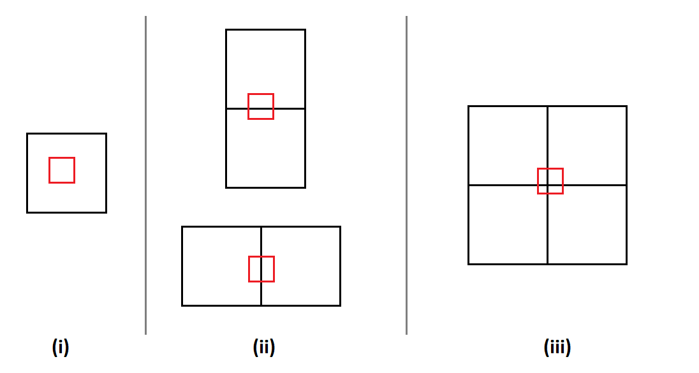
Figure 4 The three possible cases of the location of a bounding box and Mercator tiles.
Planet-Box-Extractor API detects which of these cases exist given point coordinates, zoom level, and bounding box radius. Then, the relevant tiles intersecting the bounding box are retrieved and their relative clockwise positions computed starting from the top left corner i.e., up-left, up-right, down-right, down-left. Subsequently, a single image is constructed by placing the tiles in the correct order according to their clockwise positions.
(2) Cropping the desired bounding
Once we have a single image which covers the entire bounding box, we project the coordinates of the corners of the bounding box onto the pixel space of the image using the following equation:
$$pixel_{x}=int\left(\frac{longitude-tile.west}{tile.east-tile.west}*256\right) \\ pixel_{y}=int\left(\frac{latitude-tile.north}{tile.south-tile.north}*256\right)$$
where both “pixel_{x}” and “pixel_{y}” represent the location in the image for each longitude-latitude pair of the corners of the bounding box. The “tile” variable represents the coordinates of the Mercator tile where the given longitude-latitude coordinates of interest are located, e.g., “tile.east” the longitude of the west border of the tile. The constants “256” are the size of the Mercator tiles from the Planet API. Finally, the corresponding pixels of the bounding box are cropped and exported.
4. Annotation Process
We have a set of GPS coordinates corresponding to the centers of maize fields. There were some issues in the data collection process which sometimes resulted in GPS coordinates that do not precisely coincide with their correct maize field centers. The errors in the GPS coordinates are due to recording on the edges of the field rather than the center, or in the house which owns the farm, or under the shade of a nearby tree, or even on the main road leading to the farm. Only unique datapoints of (longitude, latitude, plot-size) triples are kept, while duplicate ones are dropped.
The problem we are trying to solve is to correctly identify the original field centers given the GPS coordinates.

4.1 Manual Annotation
The GPS coordinates are projected on the map as shown in the figures below. Two target icons are drawn on the map; black indicates original position and red indicates corrected position. The area of these icons is calculated from the “plot size” variable but may not exactly match its size. Note that the icons are always circular but the field itself may be an elongated rectangular stretch or even triangular. Also, the corrected (red) field location may be somewhat far from the original (black) location.
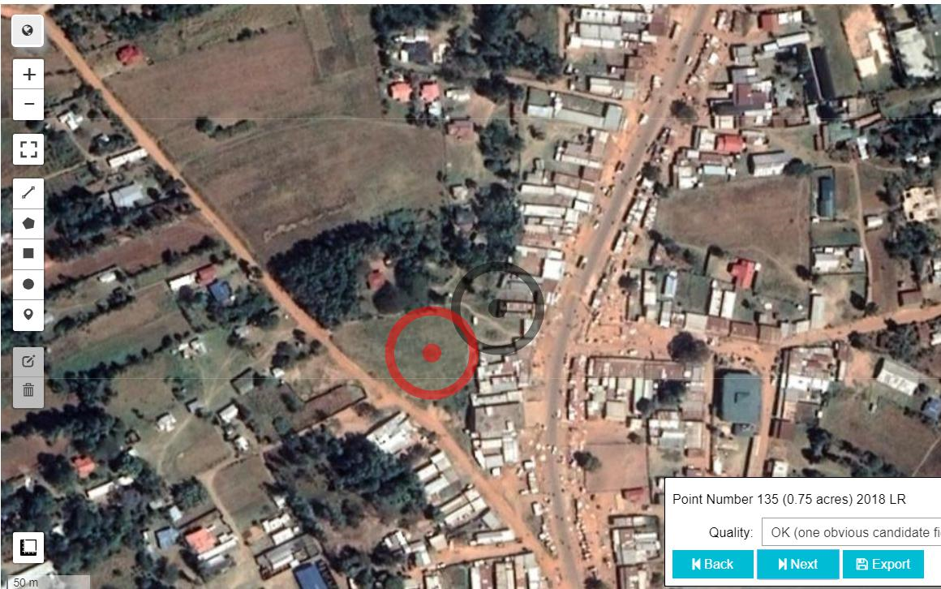
Figure 5 Example of manual annotation

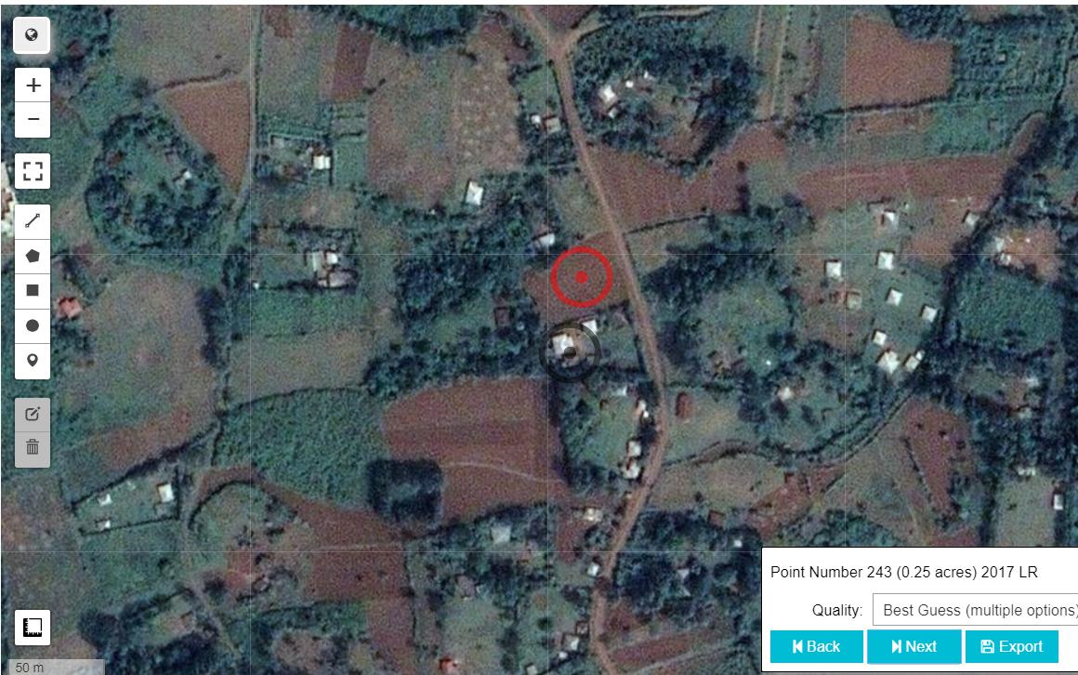
Figure 6 Example of manual annotation
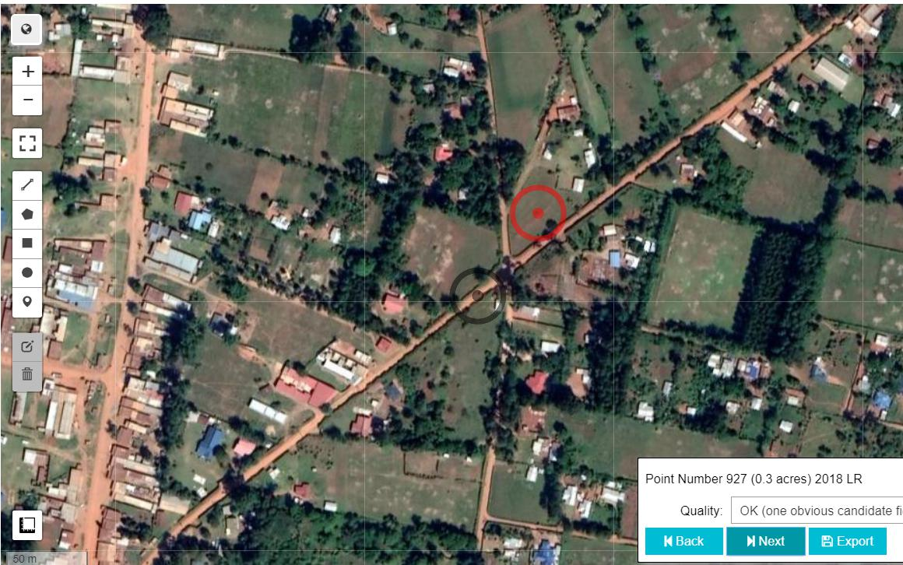
Figure 7 Example of manual annotation
4.2 Challenges
The figures 5, 6, and 7 demonstrate some of the challenges in this problem.
The image resolution in the competition data is lower than these figures, making it harder to identify the fields. We couldn’t use the same high-resolution images due to licensing issues.
Furthermore, sometimes there are multiple possible candidate target fields and the annotator has to make a best guess based on size and proximity of the field. This is captured by the “Quality” variable in the data.
Moreover, some field workers record multiple data points in the same spot making plot size the only distinguishing variable.
5. Winner Solutions
5.1 1st Place Solution
This solution is based in the idea of visual object detection, where the objects of interest are crop fields. Their approach is divided into three main parts. They use only the Planet Labs images, Sentinel-2 images are not used. The model is implemented using Python and Pytorch [8].

5.1.1 Bounding Box Labels
This stage is concerned with the analysis and exploration of the data to design the features and model parameters. The original ground truth labels are provided as the offsets to the center of the field coordinates and the data is processed such that the current center of field coordinates are at the center of the image.
The idea of this solution is to build an object detection model which can predict a bounding box on where the field is. In order to train this model, the offset coordinate labels along with the field size (acres) are converted into a radius and a bounding box surrounding the field. This bounding box is represented as 4 coordinates. See figure 8.
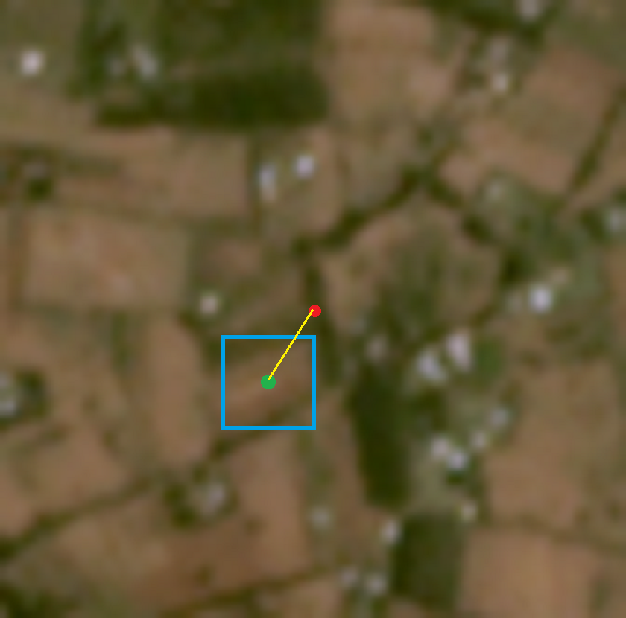
Figure 8 Example of Bounding-Box annotation. Red dot is the original center, Green is the correct center. Blue box is the estimated bounding box from the field size (acres)

5.1.2 Object Detection Model
This solution uses YOLOv5 [9] based on its performance on other object detection tasks. They use 5 cross validation folds splitting the data 5 times based on the Year, into train and test sets used to estimate unseen data generalization error. Additionally, they use these 5 models together as an ensemble for the final predictions which reduces the risk of model overfitting. They conduct various experiments to tune the final model hyperparameters.

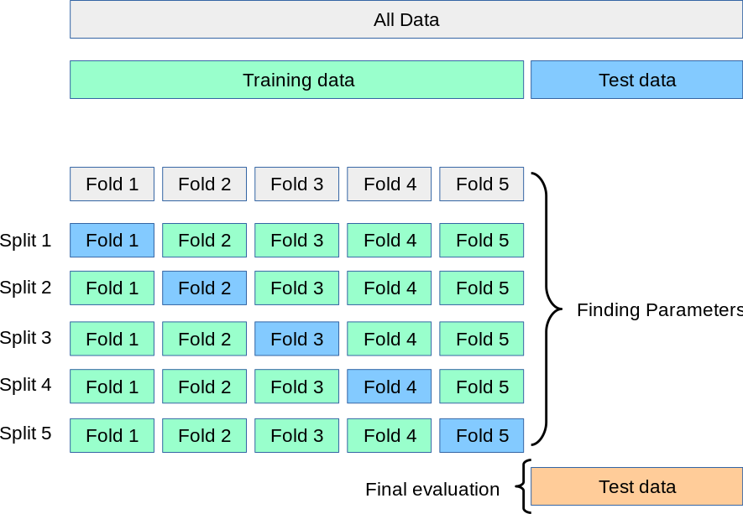
Figure 9 Cross Validation. Source: https://scikit-learn.org/stable/modules/cross_validation.html

5.1.3 Voting Mechanism
For each location of the crop there are 4 images at different times: June’17, December’17, June’18, and December’18. Therefore, the model generates 4 bounding box predictions: one for each image.
They used voting mechanism to incorporate all 4 predictions by taking their median value as the final predicted center offset. This voting mechanism helps reduce the error by taking the average over the 5 cross validation folds and taking the median over the 4 image predictions.

5.2 2nd Place Solution
This approach models the problem as a predicting the probability that each pixel is the correct center pixel of the field. First, a probability field is generated representing the probability that each pixel could be the target location. Then, a weighted median centroid is taken over the field with the probabilities as weights and this centroid location is used as the output location. The model is implemented using Python and Tensorflow [10].

5.2.1 Approach Overview
A convolution-deconvolution neural network model is trained to take preprocessed Planet Labs images as inputs and produce a 2D probability field representing the likelihood that each pixel could be the correct crop field center.
The model predicts a probability mask representing the likelihood that each pixel could be the correct center given its surroundings. However, this probability mask does not take into account the global position of each pixel i.e., the fact that pixels near the center of the image are more likely to be the correct center. To mitigate this, a separate probability mask is generated to represent the probability of a pixel being the correct center given only its global position i.e., capturing global statistics of the data. This global probability mask multiplied it with the original mask to create a combined probability mask which takes both global position and local features into account. This approach does not require training another neural network model to create the second field. Ground truth offset coordinates in the training data are almost perfectly normally distributed, so the second mask will simply be a Gaussian distribution with the same standard deviation as that of the training data. Note that this Gaussian distribution of the training data is estimated after converting from geospatial coordinates to image space coordinates.
The weighted median centroid of the combined probability mask is converted back to geospatial coordinates as predicted field center offset coordinates. Note that where a traditional weighted centroid would minimize a squared distance loss, a weighted median centroid will minimize absolute distance loss.

5.2.2 Image Preprocessing
Only Planet images are used, Sentinel images are not used. Edges are extracted as the sum of square of the Sobel operators [11] for X and Y axes across color channels, where one channel of edges is returned per image as the three color-channels (RGB) are reduced to one edge channel. Image color channels are converted to CieLab color-space [12]. The result is an output with 16 channels, 4 for each image. Images are then cropped to be 80x80 pixels.

5.2.3 Model
(i) Loss Function
The loss function used to train the model could be described as spatial binary cross entropy. It takes a 2D binary mask representing acceptable pixel answers (pixels that are acceptable answers are 1s in the mask and pixels that are not acceptable answers are 0s) as the target and a 2D probability mask (that sums to 1.0) as the prediction. The loss is computed as the negative log sum of the product of the target mask and prediction field. Note that the target mask may also contain values between 0.0 and 1.0 to represent pixels that are only somewhat accepted. In this case the target masks are Gaussian distributions which drop off very quickly with distance from the target pixel.
(ii) Architecture
The first half of the model follows the pattern:
$$Convolution→Batch Norm→Activation→Max Pool$$
It is important that the model is not able to learn the location of the edges of the image, so convolutions are mirror padded. The second half follows the pattern:
$$Upsample→Transposed Convolution→Batch Norm→Activation$$
Transposed Convolution is likewise mirror padded. After this is a dense layer and two different activations are applied each to about half of the channels, the first is the $antirectified arcsinhlu$ used for most of the network and described below, and the second is a simple $arcsinh$. Then a dense layer reduces the feature maps to a single channel. This is followed by a spatial softmax, after which the borders (those pixels near the edge of the image) of the featuremap are set to zero. This last part is done so that the model cannot learn the location of the image edges incrementally. If we did not set the borders to zero, the model would first learn to zero out the outer most pixels, then gradually those closer to the center. The final step is to rescale the feature map to sum to one as this is also necessary for the border pixels to be entirely ignored.
(iii) Activation Functions
The activation function used is nearly identical to an $ELU$:
$$F\left(x\right)=\left\{\begin{aligned}x,ifx≥0 \\ \operatorname{arcsinh}\left(x\right), otherwise\end{aligned}\right.$$
This function, which uses $arcsinh$, might have a couple advantages over the $ELU$ activation. First, unlike an $ELU$, this activation is continuous in the second derivative (the second derivative is zero at the origin.) Second, the derivative of $arcsinh$ drops off slower than that of exponential decay making this activation less susceptible to, if not immune to, saturation which may have advantages against local optima and overfitting.
Note also that concatenated $\{f\left(x\right), -f(-x)\}$ are used. When this is done with a RELU activation, it is called an$antirectified$, and it has been shown to be advantageous in some networks.
(iv) Voting Mechanism
The model is trained using 4-fold cross-validation. The prediction of these folds is combined in a geometric mean:
$$final=\sqrt[4]{p_{1}*p_{2}*p_{3}*p_{4}}$$

5.3 3rd Place Solution
This approach models the problem directly as regression: predicting the X and Y offset coordinates. Only Planet images are used from June’17. Data augmentation in the form of vertical and horizontal flipping is applied. Images are zero-padded to 84*84 pixels. This solution is implemented in Python and Pytorch.
The model consists of 3 convolutional blocks and 1 fully connected block. Each of the convolutional blocks consists of:
$$Convolution→Batch Norm→ReLU→Drop Out$$
With number of feature channels of 256. The output of the 1st block goes into the 2nd which goes into the 3rd, the final output is the addition of the 2nd and 3rd outputs:

$$f1=block1\left(image\right) \\ f2=block2\left(f1\right) \\ f3=block3\left(f2\right) \\ final=f3+f2$$
Then these final features are reshaped and passed through a series of fully connected layers:
$$Fully Connected→Batch Norm→ReLU$$
Until two final outputs are produces: X and Y offset coordinates.
The model is trained using the Adam optimizer [13] with an exponential learning rate schedule and a batch size of 16. Two differently initialized models are trained, and their predictions are averaged to produce the final predictions.

5.4 4th Place Solution
This approach models the problem as a regression problem: predicting the X and Y offsets directly. Both Planet and Sentinel-2 images are used. Data preprocessing extracts statistical features from the images to train a model.
The Normalized Difference Vegetation Index (NDVI) [14] is calculated from the Sentinel-2 bands. Then 3*3 (16) sliding windows around the center of the image are used to calculate the following features:
- Median
- Range: max – min
- Presence of Vegetation: If NDVI >= 0.6
- Presence of bare soil: If NDVI <= 0.1
- Ratio between NDVI and the median value for each month
The NDVI is calculated separately for each of the 12 months. For each pixel in the image, its standard deviation from the monthly NDVI indicates the amount of change over time. For example, areas with low standard deviation may be considered as roads or homes which do not change much over time.
Planet images are segmented using Quick-Shift Algorithm [15] with kernel sizes 3 and 4, which delineates approximately field boundaries. This is used to calculate the center of mass in which the field center is located.
The regression is optimized using Light Gradient Boosting Machine Regression (lightgbm) [16], where a separate model is trained for the X and the Y offsets. The models are trained with 3-fold cross-validation and the final predictions are the average of the 3-fold predictions.

5.5 5th Place Solution
This approach models the problem as a regression problem: directly predicting the X and Y offsets. Both Planet and Sentinel-2 images are used.
For the Planet images, the Otsu threshold [17] is applied to the image after applying Sobel edge detector. Then the image is cropped to 20*20 pixels around the center. For the Sentinel-2 images, the average value across the bands is calculated for all pixels leading to a total of 192 values, representing 16 pixel-band-averages for 12 months. Feature columns of all-zeros are removed.
A CatBoost [18] model is fine-tuned using Grid Search. The model is trained on 15-fold cross-validation and the final prediction is the average of these folds.

5.6 Summary of results

Table 2 Summary of competition solution errors as relative offsets (MAE) as well as in meters
Team |  | Mean Absolute Error | Error in Meters
 | Baseline | 0.24181738650 | 42.378 ± 33.83
1st | Corn Farmers | 0.23328263128 | 40.897 ± 34.35
2nd | murkyautomata | 0.23909879662 | 41.995 ± 34.60
3rd | mmohamed | 0.23965575425 | 42.050 ± 33.72
4th | halo22 | 0.23968039703 | 41.956 ± 33.53
5th | Proton | 0.24030214045 | 42.017 ± 33.56
 | Ensemble 1st & 2nd | 0.23347024318 | 40.964 ± 34.14

6. Final Implemented Solution
We analyzed the winning solutions and decided to use a combined solution of the 1st and 2nd solutions. The reason for this is that the 1st place model predicts bounding boxes of where the farm is. The discrete nature of this approach leads to many datapoints having invalid bounding boxes e.g., too small or too large. This disadvantage makes the model less viable for usage as the final solution. Approximately 40% of the datapoints suffer from this issue. Using both 1st and 2nd place solutions combined has a very close average error to the 1st place solution on the private test data as shown in table 2.
We prepare both 1st and 2nd place models independently and then combine their final predictions on the remaining data. Additionally, we re-train each model on all available labeled data including the test data. This is to leverage all manually annotated data which should further improve the models.

7. Conclusion
In this document we have reviewed the details of the field center correction problem and the specifics of the competition along with the data preparations. Then we explored the top 5 winner solutions illustrating their variety and ingenuity.
The top solutions managed to produce deep learning models that improve upon the baseline which is to leave the centers unchanged. These improvements are despite the challenging nature of the problem of correcting the center of maize fields.
However, not all the model predictions are perfect. Some datapoints are still too challenging e.g., figure 10. Improving the quality of the model requires access to high-resolution satellite images. More fine-grained annotations (such as field borders) may also improve the model performance since machine learning models strongly rely on the amount and quality of data available, which is the main bottleneck in solving the field center correction problem.

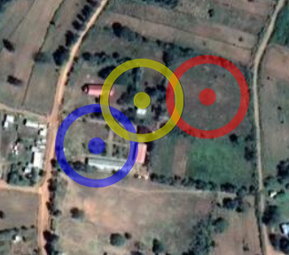
Figure 10 Example predictions. Red: Correct, Blue: 1st place solution, Yellow: 2nd place solution
References
- https://www.planet.com/
- https://sentinel.esa.int/web/sentinel/missions/sentinel-2
- http://ekenes.github.io/esri-js-samples/ge-length/
- https://planetcalc.com/7721/
- http://janmatuschek.de/LatitudeLongitudeBoundingCoordinates
- https://en.wikipedia.org/wiki/Tiled_web_map
- https://developers.planet.com/docs/basemaps/tile-services/
- https://pytorch.org/
- https://github.com/ultralytics/yolov5
- https://www.tensorflow.org/
- Sobel, I. and G. Feldman. “An Isotropic 3×3 image gradient operator.” (1990).
- https://www.iso.org/standard/52497.html
- Kingma, Diederik P. and Jimmy Ba. “Adam: A Method for Stochastic Optimization.” CoRR abs/1412.6980 (2015): n. pag.
- https://land.copernicus.eu/global/products/ndvi
- Vedaldi, A. and Stefano Soatto. “Quick Shift and Kernel Methods for Mode Seeking.” ECCV (2008).Ke, Guolin et al.
- https://lightgbm.readthedocs.io/en/latest/
- Otsu, N.. “A threshold selection method from gray level histograms.” IEEE Trans. on Systems, Man, and Cybernetics 9 (1979)
- https://catboost.ai/
- Column | Description
ImgID | Corresponding ID to the images in the data folder. For each season in June’17, December’17, June’18, and December’18.  e.g., data/jun17/id_f96fa322.png
Quality | Human annotated confidence score of the correct field centers. 0: Unavailable  1: Low Quality, Best Guess Candidate Field  2: Medium Quality, High Confidence Candidate Field 3: High Quality, Almost Certain Candidate Field Only available for manually annotated data.
human_lat | Human annotated latitude of the correct field centers. Only available for manually annotated data.
human_lon | Human annotated longitude of the correct field centers. Only available for manually annotated data.
model_lat | Model predicted latitude for the correct field centers.
model_lon | Model predicted longitude for the correct field centers.

